PulseX Report
Organised by: GDGoC - CIT

Index

Topic Page No
1. Introduction 2
2. Event Overview 2
3. Certificates Issued 4
4. Bills and Logistics 5
5. Outcomes 5
6. Acknowledgement 5

1. Introduction
PulseX – Leveraging the Power of AI was an open-innovation hackathon organized by GDGoC– CIT to encourage students to identify real-world and social problem statements and develop impactful solutions using Google technologies. The event was structured to promote innovation, feasibility, and practical implementation rather than complexity.
Conducted across three progressive phases, PulseX guided participants from idea conceptualization to partial development and finally to a fully working prototype. This phased approach enabled systematic evaluation, refinement of ideas, and focused technical execution.
The hackathon provided a platform for students to enhance their skills in ideation, system design, prototyping, and presentation while building solutions with real-world relevance and societal impact.

2. Event Overview
Phase 1: Idea Pitching
Phase 1 of PulseX, the Ideathon (Idea Pitching) round, was conducted on 22nd December 2025 at the CHOSS venue from 1:30 pm to 4:00 pm. The event received an enthusiastic response, with 31 team registrations submitted through a Google Form. This phase focused exclusively on idea pitching, with no prototype requirement, allowing teams to concentrate on clear problem identification, relevance to open innovation, real-world applicability, innovation, and feasibility of their proposed solutions. All participating teams followed the officially shared PPT template, limited to a maximum of 10 slides, to ensure consistency and clarity in presentations. Each team was allotted a total of 12 minutes—7 minutes to pitch their idea and 5 minutes for a questionnaire and interaction with the judging panel.
Evaluation was conducted using a structured Phase 1 evaluation sheet, assessing problem understanding and relevance, innovation and uniqueness, solution feasibility, use of Google technologies, technical architecture and design, features and functionality, presentation and communication, future scope and impact, and documentation readiness. The panel of judges for this phase comprised of Prof. Dr. Karthik.P (ISE Dept), Prof. Dr. Loganathan D (ISE Dept), Assoc.Prof. Dr.Girija.V (CSE Dept) and Asst.Prof.Sunil Kumar K.N (ISE dept). Based on clarity, impact, practicality, and overall performance, 10 teams were shortlisted out of 31 and qualified for the next phase. The smooth conduct of the ideathon and active participant engagement were documented through image proof captured during the event.
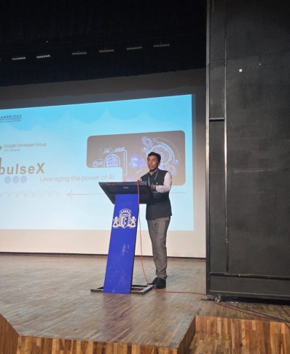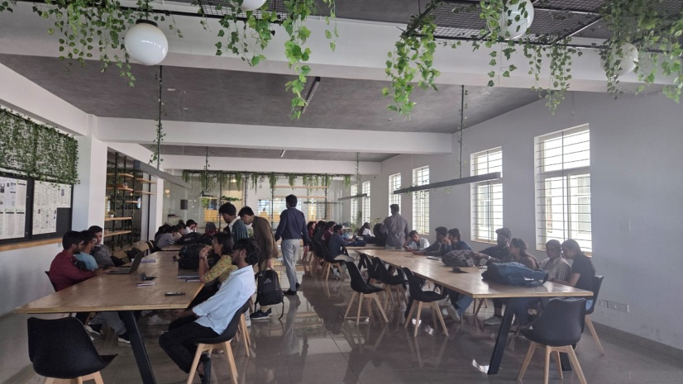

Phase 2: Partial Prototype Phase
Phase 2 of PulseX was conducted on 8th January 2026 at CHOSS space from 1.30pm to 4.00pm, focusing on evaluating the technical progress and partial implementation of the shortlisted teams from Phase 1. In this round, teams were required to present a basic or partially working prototype demonstrating core functionalities, system architecture, and feasibility of their proposed solutions. The prototype was not expected to be fully functional; however, teams were required to clearly justify their technical approach and highlight meaningful integration of Google technologies.
Each team was allotted a total of 15 minutes, comprising 3 minutes for PPT explanation, 7 minutes for partial prototype demonstration, and 5 minutes for a Question & Answer session with the judging panel. Evaluation was conducted using a 100-mark structured judging sheet, assessing progress from Phase 1, UI availability and logic integration, depth and correctness of Google technology usage, partial prototype functionality, architecture alignment, technical effort, demo clarity, and readiness for the final phase. The panel for this phase included Assoc.Prof. Dr. Yashaswini.S (CSE Dept), Assoc.Prof.Dr.Girija.V (CSE Dept) and Asst.Prof.Sunil Kumar K.N (ISE dept), Asst.Prof.Vijayalaxmi (ISE Dept) based on whose evaluation 6 teams were shortlisted to advance to the final round. Image evidence documenting team presentations and jury interactions was captured during the event.
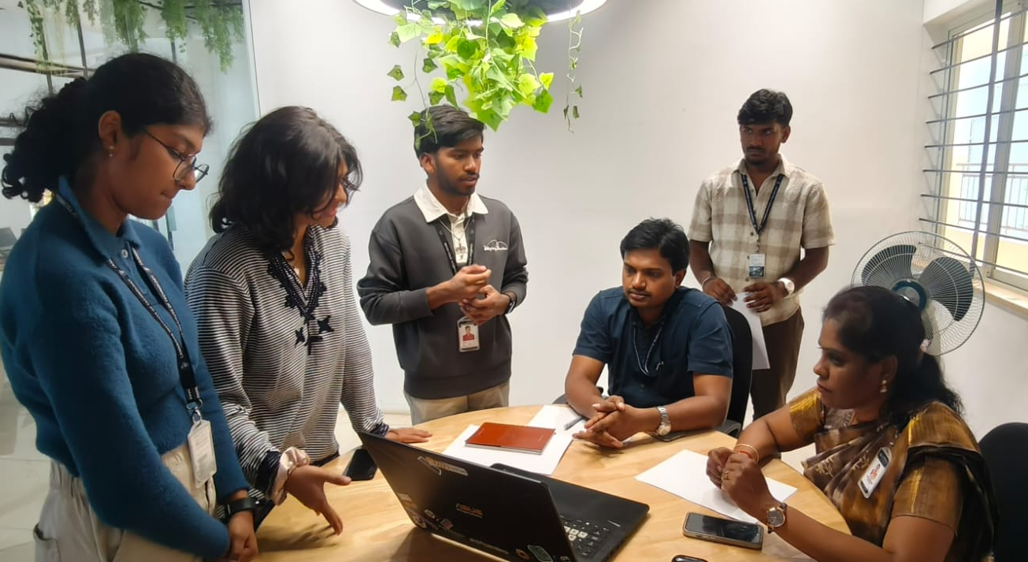
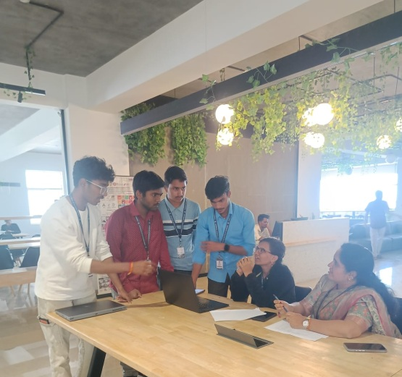
Phase 3: Full working Prototype
Phase 3 marked the final and most critical stage of the PulseX Techfest, where 6 shortlisted teams presented their fully working end-to-end prototypes. This phase was conducted at the CHOSS Space in CIT Bengaluru on 16th January 2026, between 1.30pm and 4.00pm and focused on evaluating the completeness, usability, and real-world readiness of the proposed solutions. Each team was allotted 7 minutes to pitch their solution followed by 5 minutes of Q&A, during which judges assessed both technical depth and clarity of understanding. Evaluation was carried out using a structured 100-mark judging sheet, covering full prototype completion and core functionality which carried 20 marks each, live demo quality for 15 marks, UI/UX , effective Google technology integration, technical depth and engineering effort for 10 marks each, scalability and real-world readiness, presentation clarity, and Q&A performance. The judging panel comprised Assoc.Prof.Dr.Priyanka Desai (ISE Dept), Asst.Prof.Sunil Kumar K.N (ISE Dept) and Mr. Aaron Noel D’Souza who provided detailed feedback and scoring for each team. Based on the final evaluations, 3 teams emerged as the winners.
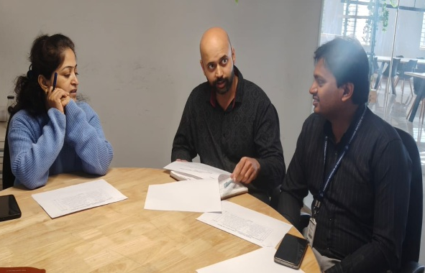
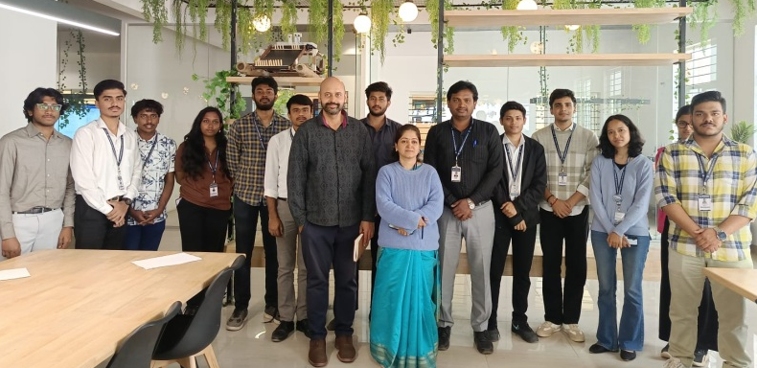

3. Certificates Issued
Participation certificates were issued to all registered participants across all phases of the PulseX Hackathon. Winners were awarded certificates of achievement along with medals, while all finalist teams received certificates and curated goodies as a token of appreciation for their efforts. The judges and panel members were presented with certificates of appreciation in recognition of their valuable time, expert evaluation, and guidance contributed towards the successful conduct of the event.
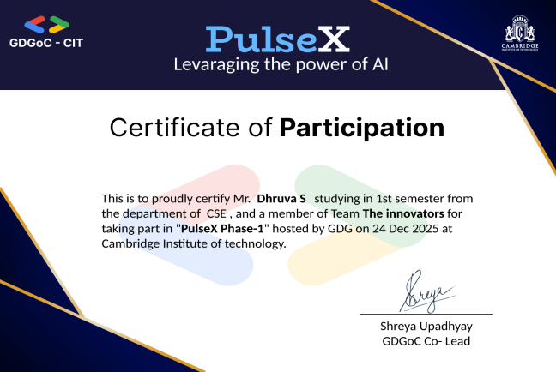
Few sample certificates:
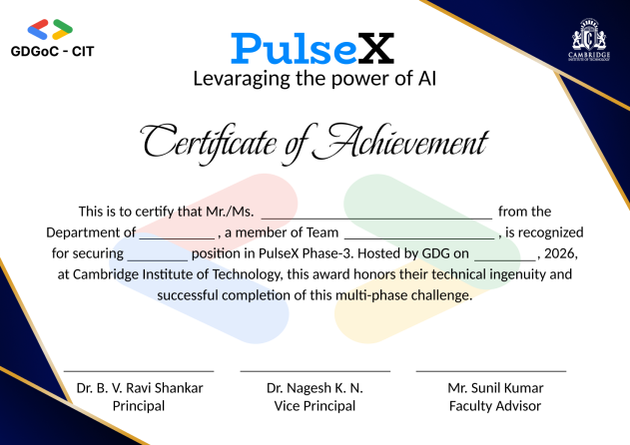
4. Bills and Logistics

Logistics Management
The logistics for PulseX were planned and executed to ensure the smooth conduct of all three phases of the hackathon. Necessary arrangements were made for venue allocation, seating, presentation facilities, and overall event coordination. Infrastructure requirements were arranged in advance. Separate provisions were made for the judging panel, organizing team, and participants to facilitate uninterrupted presentations and evaluations. Volunteers were assigned for registration management, timekeeping, coordination with teams, and assistance to the panelists during all phases of the event.

Financial Details and Bills

All expenses incurred during the organization of PulseX were carefully documented and supported with valid bills and invoices. The expenditures primarily covered certificates, printing requirements, and miscellaneous logistics. The total expenditure was maintained within the approved budget and verified by the team.

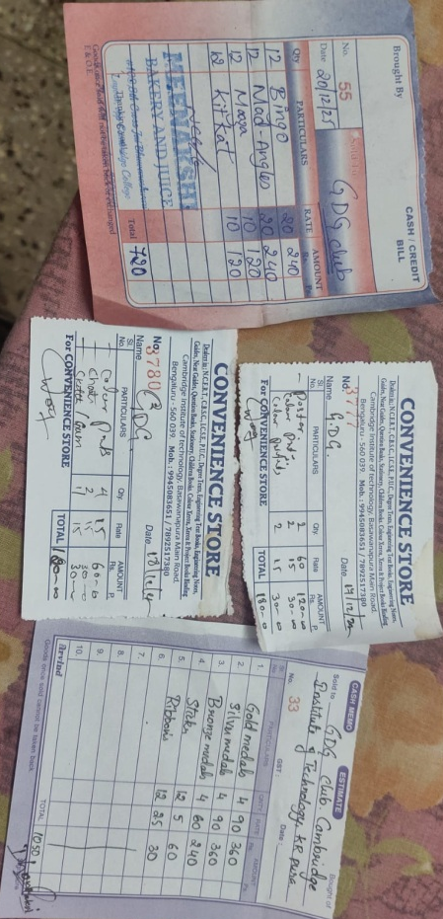

5. Outcomes
The PulseX Hackathon provided a structured platform for students to progress from ideation to full-scale prototype development, emphasizing real-world problem-solving, feasibility, and innovation. Through its phase-wise format, participants gained hands-on experience in applying modern technologies, refining technical architecture, and delivering functional solutions. The hackathon enhanced students’ technical, analytical, and presentation skills while encouraging collaboration and creative thinking. Overall, PulseX successfully fostered an innovation-driven mindset and offered students valuable exposure to industry-relevant tools and practices.

6. Acknowledgement
We extend our sincere gratitude to the Management of Cambridge Institute of Technology for their constant support and encouragement in making the PulseX a successful event. We express our heartfelt thanks to the Principal, Dr.B V Ravishankar and the Vice Principal, Dr.Nagesh of Cambridge Institute of Technology for their valuable guidance, motivation, and approval, which ensured the smooth planning and execution of the event. We are especially thankful to the Faculty Coordinator, Asst.Prof.Sunil Kumar K.N, for their continuous support, effective coordination, and dedicated involvement throughout the event. We also extend our sincere appreciation to the esteemed jury panel members for their time, expertise, and constructive feedback, which greatly enriched the learning experience for all participants. The mentorship and commitment of everyone involved played a vital role in organizing PulseX and in providing students with a meaningful platform to explore technology, innovation, and collaborative learning.

